CIS 634 Object Oriented Software Engineering Course Project

TICKETING TOOL GROUP – 4

Test Specifications of Ticketing Tool Project

INTRODUCTION

This is simply a documentation of the software test plan for the ticket issuing system for an organization. The project goal and main objective for this system is to provide the automated ticket selling for public uses. The document will therefore cover in detail, the information about testing plan and test cases used for this project.
The target audience for this project is for public use, however, managed and run by any organization that buys and owns it. We will utilize test criterions under several testing methods consisting of white box, black box and system testing paradigm which comprises stress testing, and other testing practices.

Goals and Objectives

The main objectives are as follows:

Provision of 24-hour service - The system is expected to provide a service that lasts about 24 hours. Capable of providing service without stopping and going off.
Provision of selling tickets to clients - The system is expected to have the tickets sold in a concise and in a manageable way.
Provision of event creation and management - Events are created in the system and, should be capable of managing the events created.
Provision of report management - Capable of report management. Able to create reports in respect to tickets, events, clients registered, so on and so forth.

Statement of Scope
This part consists of scope of work the system will be able to handle and the product description and the requirements needed to set up the system as well as build it.

The scope of the project is as follows:
Developing a suitable ticketing system is part of the scope.
Event management is and will be part of the scope. Creating events, as well as managing created events.
Ticket selling and issuance will be part of the scope. Authentication of the users to the system is part of the scope.

Out of scope:
Settings management and authentication permission issuance is out of scope.
Development and Management of the team plan is out of scope. Management of financial plan and budget allocation is out of scope.

Test Plan
In our testing process, we will be applying the same test specifications that are well described in the IEEE Standard 829 software testing documentation. Several test strategies will be used including the tech stack as well as environment, and tools to use while testing.
We will as well look at the test plan timetable which lists all the activities that should take in the testing process, that is, in respect to time. The test

plan simply aligns the schedule of the testing process to make sure good quality assurance is met.

Software tested

The software here are tested simply consists of what and where to be tested in the ticketing tool system. The exclusivity on testing comprises those tests which are fully implemented and hence the test cases are working fine and yet more test cases will be added in future.

The test inclusions are as follows:
    - Authentication of the users.
    - Event creation in the system.
    - Management of the events.
    - Ticket selling and issuance.
    - Ticket status and creation of tickets.
    - Settings for the system.
    - High workloads on the server.
    - Debit and Credit Cards.
    - Network congestion and display.
    - SMS and Several API Gateways.

Testing Tools and Test Environment

The environment setup needed is such of an office. Why? This is because much of the needs are kind of office tools. Testing tools are simply the tools needed in the process of testing of the system. The system being internet based, we can test it anywhere and everywhere one resides. However, some requirements are needed to have before making a step of testing this software.

The tools must comprise of the following:
    - One Network Controller
    - Three network PC’s, With Main Known Operating system, Windows, Mac, Linux.
    - Oracle or Microsoft MySQL server.
    - RAM: 2 GB RAM or above
    - Hard Disk: 20 GB hard disk or above.
    - Integrated Development Environment – Visual Studio Code.
    - Several Known Browsers - Main Browser to have will be Chrome, Firefox, and Safari browser.
Test Schedule and Milestones:

This simply refers to the test plan of the project processes. Comprises a test plan aligned in respect to the predefined date for project development

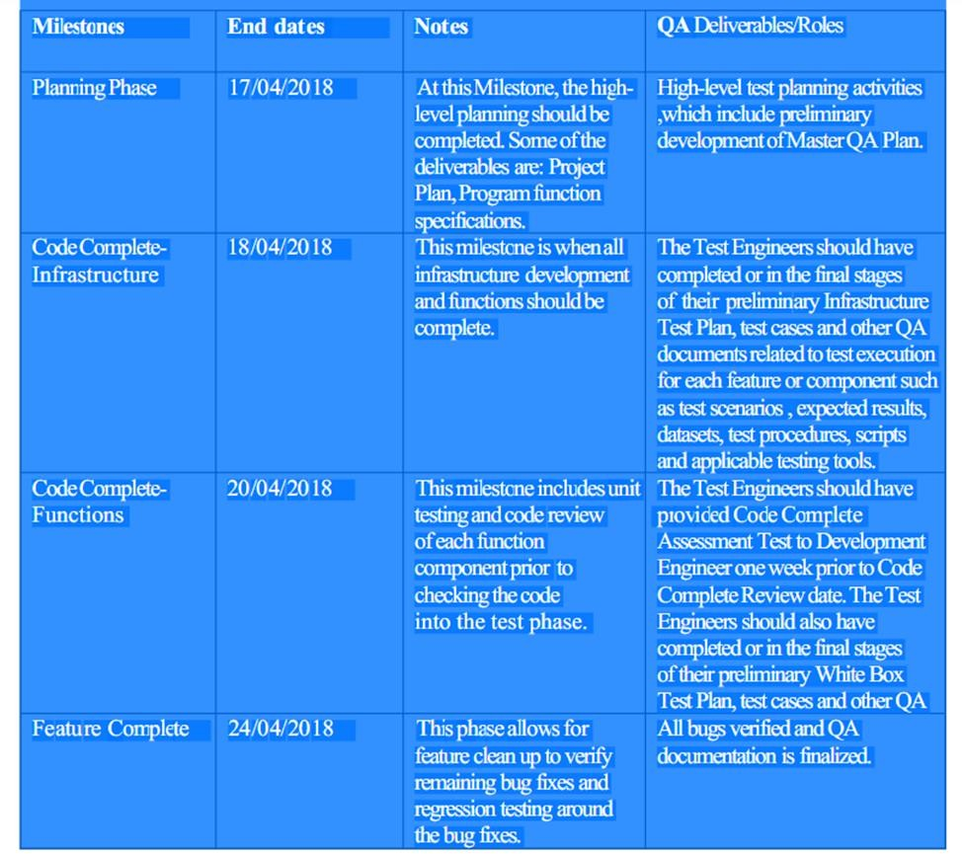
3.0 Test Cases
Test cases consist of test methods used to facilitate the project testing process. The methods were not limited to testing paradigms of the project.

We shall have the test case methods as follows:
ID | Test Case Title | Test Input | Expected Output | Description | Result
1 | User Registration | User’s name, email ID, contact and password | Creates the user and able to login | User registration page | Pass
2 | Authentication of the users | Username and Password | Successful login and navigated to homepage | User can login without any issues with his/her login credentials | Pass
3 | Validating the user credentials | Login Id and Password | Successful login and Dashboard pops-up | To validate the user entered valid credentials | Pass
4 | Dashboard Access | online interface, or page in your website, that displays real-time data as insightful charts and reports | to show a comprehensive overview of data from different sources | Users can manage their ticket raised from the Dashboard | Pass
5 | Create a ticket | Contact, address, event name and charges | Successful ticket raised | To create, manage, and maintain a list (or lists) of customer problems | Pass
6 | Managing raised ticket | Admin credentials, only admin have access | Solve the raised ticket | To provide a solution for customers problems | Pass
7 | Event creation in the system | To describe the type of ticket raised | To create an event | This allows us to understand which type of ticket is raised | Pass
8 | Manage events | Admin credentials, only admin have access | Successful creation of an event | To create an event for frequently raised tickets | Fail

3.0 Test Cases continued:

ID | Test Case Title | Test Input | Expected Output | Description | Result
9 | Create clients | Required clients’ details name, address, contact info | Successful registration of client | Create more clients for improved developments | Pass
10 | Manage clients | Admin credentials, only admin have access | To manage the created clients | To manage the created clients | Fail
11 | User management | Admin credentials, only admin have access | To manage user Grant Authentication type | Grant Authentication type | Pass
12 | Settings tab | Login Id and Password of user | Pops-up the settings page | Allows to edit the user credentials and details | Fail

Note: The test cases performed above are not final test cases and need some correction and debugging for respective program file.

